**FitFlex: Your Personal Fitness Companion**

**1. Introduction**

FitFlex is an innovative and user-friendly fitness application designed to revolutionize how individuals explore and engage with workouts. The platform provides users with a **comprehensive exercise database**, allowing them to discover workouts based on their **fitness goals, body parts, or available equipment.** FitFlex integrates **cutting-edge technology** with an **intuitive design**, ensuring users can seamlessly navigate the app and access workout-related information effortlessly.

With the growing demand for **personalized and interactive fitness solutions**, FitFlex leverages **RapidAPI** to fetch real-time exercise data and integrates YouTube workout videos to enhance users’ training experience. The platform aims to bridge the gap between fitness enthusiasts and structured workout plans by offering a **visual and data-driven approach to exercise selection.**

FitFlex is more than just a workout directory—it is a **community-driven fitness companion** that motivates individuals to stay consistent, explore new workouts, and achieve their fitness goals. Whether you are a **beginner, intermediate, or advanced fitness enthusiast**, FitFlex provides a **customized** and **engaging** approach to **fitness exploration and execution**.

**Team Members:**

SATHISH A - Team Leader

SANTHOSH K - Developer

SATHYANARAYANAN S - Developer

SIVA K - Developer

**2. Project Description**

🏋️‍♂️ Welcome to the forefront of fitness exploration with FitFlex! Our innovative fitness app is meticulously designed to revolutionize the way you engage with exercise routines, catering to the diverse interests of both fitness enthusiasts and seasoned workout professionals. With a focus on an intuitive user interface and a comprehensive feature set, FitFlex is set to redefine the entire fitness discovery and exercise experience.

💪 Crafted with a commitment to user-friendly aesthetics, FitFlex immerses users in an unparalleled fitness journey. Effortlessly navigate through a wide array of exercise categories with features like dynamic search, bringing you the latest and most effective workouts from the fitness world.

🌐 From those embarking on their fitness journey to seasoned workout aficionados, FitFlex embraces a diverse audience, fostering a dynamic community united by a shared passion for a healthy lifestyle. Our vision is to reshape how users interact with fitness, presenting a platform that not only provides effective exercise routines but also encourages collaboration and sharing within the vibrant fitness community.

🔥 Embark on this fitness adventure with us, where innovation seamlessly intertwines with established exercise principles. Every tap within FitFlex propels you closer to a realm of diverse workouts and wellness perspectives. Join us and experience the evolution of fitness engagement, where each feature is meticulously crafted to offer a glimpse into the future of a healthier you.

🏋️‍♀️ Elevate your fitness exploration with FitFlex, where every exercise becomes a gateway to a world of wellness waiting to be discovered and embraced. Trust FitFlex to be your reliable companion on the journey to staying connected with a fit and active lifestyle.

**3. Project Goals and Objectives**

FitFlex aims to provide a **seamless, engaging, and data-driven fitness experience** for users of all fitness levels. The primary objectives of the platform include:

## ****1. Simplifying Workout Discovery****

🔹 Enable users to easily search for exercises based on muscle groups, difficulty levels, or available equipment.  
🔹 Provide a user-friendly **search and filtering system** that helps users find relevant workouts in seconds.

## ****2. Enhancing Exercise Understanding****

🔹 Offer **detailed exercise descriptions** to ensure proper form and technique.  
🔹 Integrate **YouTube video tutorials** to provide **visual guidance** for better workout execution.  
🔹 Reduce the risk of **injuries and poor form** by offering accurate exercise demonstrations.

## ****3. Leveraging Real-Time Data for Accuracy****

🔹 Utilize **RapidAPI integration** to fetch **up-to-date** exercise information dynamically.  
🔹 Ensure that users always have access to the latest **workout trends and fitness techniques**.  
🔹 Eliminate misinformation by sourcing data from **reliable and verified fitness resources**.

## ****4. Providing a Personalized Fitness Experience****

🔹 Allow users to **filter workouts based on their fitness level** (Beginner, Intermediate, Advanced).  
🔹 Develop an AI-driven feature (future enhancement) that suggests **customized workout plans** based on user preferences.  
🔹 Enable users to **track their workout progress** (future update) to enhance motivation and consistency.

## ****5. Promoting Accessibility & Engagement****

🔹 Ensure **responsive design**, making FitFlex accessible on **mobile, tablet, and desktop** devices.  
🔹 Provide an **intuitive and modern UI** that enhances user interaction and engagement.  
🔹 Create an **inclusive platform** that caters to **beginners, fitness enthusiasts, and professionals** alike.

## ****6. Eliminating Barriers to Fitness Knowledge****

🔹 Provide a **free-to-access** platform, removing the need for costly subscriptions.  
🔹 Offer a **comprehensive exercise database** with valuable workout insights.  
🔹 Make fitness knowledge accessible to everyone, regardless of location or background.

## ****7. Encouraging Community & Social Engagement**** (Future Objective)

🔹 Introduce a **community-driven space** where users can share workouts, rate exercises, and exchange fitness tips.  
🔹 Implement a **social engagement feature** that allows users to follow fitness influencers and trainers.  
🔹 Create a motivation-driven platform that **encourages accountability and progress sharing**.

**4. Features of FitFlex**

FitFlex is designed to **stand out from traditional fitness applications** by offering a **user-friendly, API-integrated, and data-rich experience.**

🌟 **Intuitive User Interface & Smooth Navigation** – FitFlex provides a visually appealing and easy-to-use design that enhances user experience.  
📚 **Comprehensive Exercise Database** – Users can access detailed workout information, including targeted body parts, required equipment, and difficulty levels.  
🎥 **YouTube Workout Integration** – Users can watch tutorial videos related to each exercise for better execution.  
⚡ **Advanced Search & Filter System** – Users can find exercises based on specific criteria, ensuring a tailored fitness experience.  
📈 **Real-Time Data Fetching with RapidAPI** – FitFlex dynamically fetches exercise-related data, ensuring up-to-date and accurate workout recommendations.  
📲 **Responsive & Mobile-Friendly Design** – The platform is optimized for **all devices**, ensuring accessibility from desktops, tablets, and mobile phones.  
💡 **Subscription & Community Engagement** – Users can subscribe for regular fitness tips and updates.

**5. Technical Architecture**

FitFlex is structured to ensure a smooth and efficient experience:

* **Frontend:** Built using **React.js**, ensuring high responsiveness and dynamic rendering.
* **Routing:** Managed using **React Router Dom** for seamless navigation between different pages.
* **API Integration:** Fetches exercise data from **RapidAPI** using **Axios**.
* **UI/UX Design:** Styled with **Bootstrap or Tailwind CSS** for a modern and engaging look.
* **Data Handling:** Exercises and categories are fetched dynamically to improve performance.

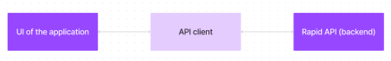

**6. Setup Instructions**

## ****Installation Steps****

### ****1. Clone the Repository****

Open a terminal and run:

git clone https://github.com/Sathishbhupa/Fitness-app-React-

cd Fitness-app-React-

### ****2. Install Dependencies****

Run the following command in the project directory:

npm install

### ****3. Set Up Environment Variables****

Create a .env file in the root directory and add the required environment variables:

PORT=5000

MONGO_URI=mongodb://localhost:27017/your-database-name

JWT_SECRET=your-secret-key

### ****4. Start the Development Server****

Run the following command:

npm run dev

or, if using Yarn:

yarn dev

### ****5. Access the Application****

* The frontend should be accessible at http://localhost:3000 (if applicable).
* The backend API should be accessible at <http://localhost:5000>

**7. Folder Structure**

**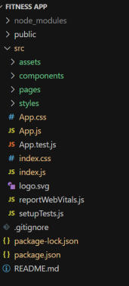  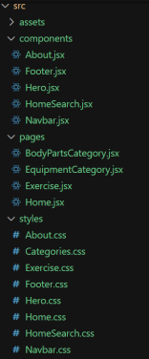**

In this project, we’ve split the files into 3 major folders, *Components, Pages and Styles.* In the pages folder, we store the files that acts as pages at different URLs in the application. The components folder stores all the files, that returns the small components in the application. All the styling css files will be stored in the styles folder.

FitFlex is organized into three primary folders:

📂 **Components** – Contains reusable UI components (Navbar, Search, Exercise Cards).  
📂 **Pages** – Stores different pages (Home, Category Page, Exercise Details).  
📂 **Styles** – Contains **CSS** files for styling the app.

**8. Running the Application**

## ****Start the Frontend Server****

Navigate to the client/ directory and run:

bash

CopyEdit

cd client

npm install # Install dependencies

npm start # Start the React development server

This will start the React app on **http://localhost:3000** by default.

# 9. ****Component Documentation****

## ****1. Key Components****

### ****Navbar****

**Purpose:** Navigation bar with links to home, shop, cart, and authentication.  
**Props:** user, cartItems, onLogout

### ****Cart****

**Purpose:** Displays cart items with update and remove options.  
**Props:** cartItems, onUpdateQuantity, onRemoveItem

## ****2. Reusable Components****

### ****Button****

**Props:** text, onClick, variant

### ****Loader****

**Purpose:** Displays a loading spinner.

**10. API Integration & Data Fetching**

**Fetching Exercise Categories**

FitFlex retrieves **exercise data** dynamically from the **RapidAPI Exercise Database.**

const bodyPartsOptions = {

method: 'GET',

url: 'https://exercisedb.p.rapidapi.com/exercises/bodyPartList',

headers: {

'X-RapidAPI-Key': 'YOUR_API_KEY',

'X-RapidAPI-Host': 'exercisedb.p.rapidapi.com'

}

};

const fetchData = async () => {

try {

const response = await axios.request(bodyPartsOptions);

setBodyParts(response.data);

} catch (error) {

console.error(error);

}

};

**Fetching Exercises by Category**

const fetchData = async (id) => {

try {

const response = await axios.get(

`https://exercisedb.p.rapidapi.com/exercises/equipment/${id}`,

{ headers: { 'X-RapidAPI-Key': 'YOUR_API_KEY' } }

);

console.log(response.data);

} catch (error) {

console.error(error);

}

};

**Fetching Related YouTube Videos**

const fetchRelatedVideos = async (name) => {

const options = {

method: 'GET',

url: 'https://youtube-search-and-download.p.rapidapi.com/search',

params: { query: `${name}` },

headers: { 'X-RapidAPI-Key': 'YOUR_API_KEY' }

};

try {

const response = await axios.request(options);

console.log(response.data);

} catch (error) {

console.error(error);

}

};

**11. User Interface**

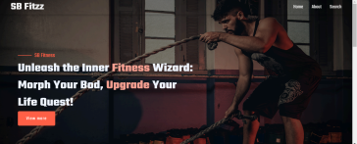

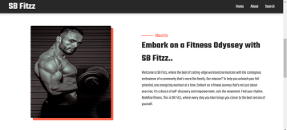

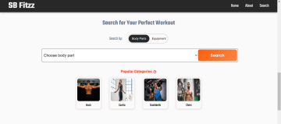

# 12.Styling

**1. CSS Frameworks/Libraries**

* **Tailwind CSS**: Used for utility-first styling, responsive design, and consistent UI.
* **Styled-Components** (if used): Allows for component-level styling with dynamic props.
* **React Icons**: Provides scalable vector icons.

**2. Theming & Custom Design System**

* **Global Styles**: Defined in index.css (or global.css for Tailwind setups).
* **Theme Configuration** (if applicable):
  + Dark mode support using Tailwind's dark: variants.
  + Custom color palettes defined in tailwind.config.js.
* **Reusable Style Components**: Buttons, modals, and input fields follow a design system for consistency.

**13.Testing**

**1. Testing Strategy**

* **Unit Testing**:
  + **Tool**: Jest & React Testing Library
  + **Purpose**: Tests individual components to ensure they render and function correctly.
  + **Example**: Checking if a button renders with the correct label.
* **Integration Testing**:
  + **Tool**: React Testing Library
  + **Purpose**: Ensures multiple components work together as expected.
  + **Example**: Verifying if a form updates state correctly when inputs change.
* **End-to-End (E2E) Testing**:
  + **Tool**: Cypress or Playwright
  + **Purpose**: Tests user interactions in a real browser environment.
  + **Example**: Simulating a user signing in and navigating through the app.

**2. Code Coverage**

* **Tool**: Jest with --coverage flag
* **Goal**: Ensures that key components, functions, and critical paths are tested adequately.
* **Reports**: Generates coverage reports to track untested code areas.

**14. Screenshots or Demo**

**Hero component**



**About**



**Search**



**Category page**

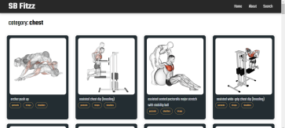

**Exercise page**

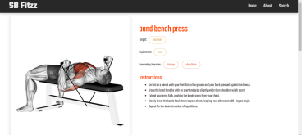

Demo link: <https://drive.google.com/file/d/1RJCqOD39B69TN3NEMHoNe63cbb4Fb4aI/view?usp=drive_link>

# 15.Future Enhancements

**1. New Features & Components**

* **AI-Powered Chatbot**: Integrate an AI assistant for customer support.
* **Wishlist & Favorites**: Allow users to save products for later.
* **Personalized Recommendations**: Implement a recommendation engine based on user behavior.

**2. UI/UX Enhancements**

* **Dark Mode & Theming**: Add support for multiple themes.
* **Advanced Animations**: Use Framer Motion for smooth transitions and effects.
* **Microinteractions**: Improve UI responsiveness with hover and click effects.

**3. Performance & Optimization**

* **Lazy Loading**: Optimize page performance by loading components dynamically.
* **Server-Side Rendering (SSR)**: Implement SSR with Next.js for faster page loads.
* **Image Optimization**: Use modern formats like WebP and lazy loading for images.

**4. Testing & Security**

* **End-to-End Testing**: Enhance test coverage with Cypress for complete user journey validation.
* **OAuth & Social Login**: Implement Google, Facebook, and Apple login for better accessibility.
* **Security Enhancements**: Improve authentication and data encryption measures.

**16. Conclusion**

FitFlex is an **innovative fitness application** designed to enhance the **workout experience** through intuitive UI, **powerful search features**, and **real-time exercise data integration.** The app is built with a **scalable React.js architecture** and provides a **seamless** and **engaging** fitness journey for users.